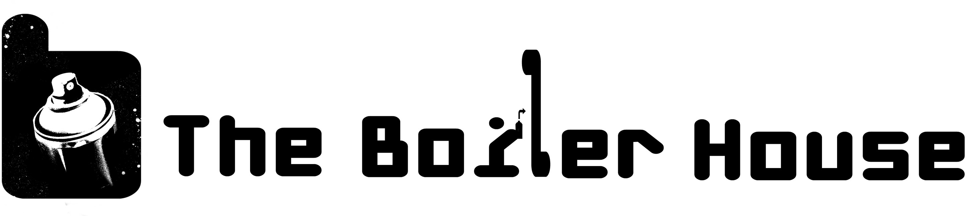

Birthday Graffiti Workshop Sessions

The participants work with a Graffiti Artist to learn the basics of Graffiti Art in The Boiler House. The Boiler House is a Graffiti Art gallery where the walls are completely covered in inspirational artwork. They work as a team to paint a large Graffiti piece on 8x4 wooden boards with an Artist guiding them throughout. We aim for the sessions to be as practical as possible and we keep group sizes small so that everyone is engaged and gets plenty of painting time. The sessions are informal, super creative and fun.

Q – How long are the sessions?
The sessions last from 1.30hrs to 2hrs long depending on the group.

Q – How old do you have to be to do them?
The minimum age is 10 years (10th Birthdays are fine). Adult birthday sessions are welcomed too!

Q – How many people can you have?
10 at the most in one session.

Q – Can we bring food?
Solvent spray paint and food are not a great mix so we do not allow food at the workshop sessions. You are welcome to bring a cake to give out at the end of the session with party bags etc. Locally we have Ollie’s Bar and Dusty’s Pizzeria on the same road where you can go for food after the session.

Q – What should I wear?
Please ask participants to wear old clothes although they are unlikely to get any paint on themselves. The Boiler House is a warehouse space so in winter dress accordingly. Now due to Covid we ask all participants to wear their own masks for the session.

Q – Do we take the artwork home?
For beginners controlling a spray can is not easy, and to get good results the participants need to paint BIG. Therefore after 15 years of delivering workshop sessions we have found children are happiest with the results when they work together on a large piece when guided by an Artist. We ask that you bring camera's/phones to take pictures of their work. The Boiler House provides great photo opportunities.

Q – Are there facilities at the venue?
The Boiler House is a warehouse space, there are benches for onlookers to sit during the session but we ask that only two adults maximum stay for the session. Due to Covid regulations we ask that participants have been to the toilet before the session but if anyone is caught short there are shared facilities on the industrial estate that can be used if required.

Q – Where is the Boiler House?
The Boiler House address is Unit D, Papermill Rd, Canton, CF11 8DH. We are just passed 'Ninja Dragons'.

Q – Can I park at the Boiler House?
Yes there is plenty of parking.

Q – If my party booking starts at 11am what time should arrive?
There is no paperwork to fill out and no waiting area so please arrive at the start time of the workshop ie. 11am. The space will not be open before the start time.

Q – What Covid regulations are in place?
The sessions are run with the roller shutter door of the unit wide open so there is plenty of air flow, we ask all participants to hand sanitise on arrival and to wear their own masks to the sessions. We save the details of the person who booked who we can then contact if required by track and trace. We discourage use of the shared onsite toilets where possible.

